表1 实验算例的选取
 | m | n
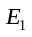 | 3 | 5, 8, 10, 15, 20 | 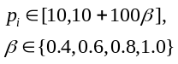
 | 5 | 10, 12, 15, 18, 20
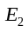 | 3, 5 | 50, 100, 200
 | 10 | 25, 50, 100
 | 15 | 20
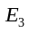 | 3, 5 | 500
 | 10 | 200, 500
 | 15 | 100, 200, 500
 | 100 | 200, 500, 1000

